**Project Information**

**Details about LockedMe.com application:**

In first step I have planned two sprints Sprint 1 and Sprint 2

**Sprint 1**

**Story:**

Code to show the welcome screen, it should show the welcome screen.

**Task 1:**

Welcome screen should show the name of application and the developer’s name.

Option to show the user interaction information.

**Feature 1:**

Display the options for user interaction:

1.Show files.

2.Business level operations.

3.close app.

**Feature 2:**

Feature to accept the user input to select one of the options listed.

In Sprint 1 i have done following points:

1. I have set my working directory and then started working on the project.

2. Implement code for displaying welcome screen which includes application name and the developer’s name.

3. Implement three options

* Show files
* Business level operations
* Exit from application

4. Implement Scanner class for taking user’s input

5. Here user can interact with the application which is a command line-based application.

In this process three methods are defined.

|  |  |
| --- | --- |
| welcomeScreen() | This method prints application name and developer’s name. |
| optionscreen() | This method prints three options (Show files, Business level operations & exit from app) |
| inneroptionocreen() | This method prints four options which are (Create new file, delete a file, search a file & return to main context) |

**Sprint 2**

**Story 1**

The first option should return the current file names in ascending order. The root directory can be either empty or may contain few files or folders.

**Story 2**

The second option should return the details to the user interface such as options displaying the following.

**Task 1**

Create a method to add a file to existing directory list.

You can ignore the case sensitivity of the file name.

You can also give an option to write in file.

**Task 2**

Create a method to delete a user specified file from the existing directory.

Display the message if file is not found.

You can use case sensitivity to ensure that right file is deleted.

**Task 3**

Create a method for search user specified file.

You can use case sensitivity on file to search a right file.

Print a message on successful action.

Print the message if action is failed.

**Task 4**

Option to navigate back to the main context.

**Task 5**

Option to exit the app.

In Sprint 2 i have done following points:

|  |  |
| --- | --- |
| createfile(String filename) | This method checks if a file already exists with given name then it will not create again and prints the message else creates new file with given name. |
| deletefile(String filename) | This method will delete the file with given name if file not exists then it will print message of file not found. |
| searchfile(String filename) | This function searches the file in directory and prints the message. |
| displayfiles() | This method will print all file’s name in ascending order. |
| write(String filename, String data) | This method will writes given data in file if file exists else prints message. |

In main method objects of all classes are created and also invoked methods of respective classes.

Concepts are used in development:

|  |  |
| --- | --- |
| File Handling | File handling is used for create, delete, search and display all files. |

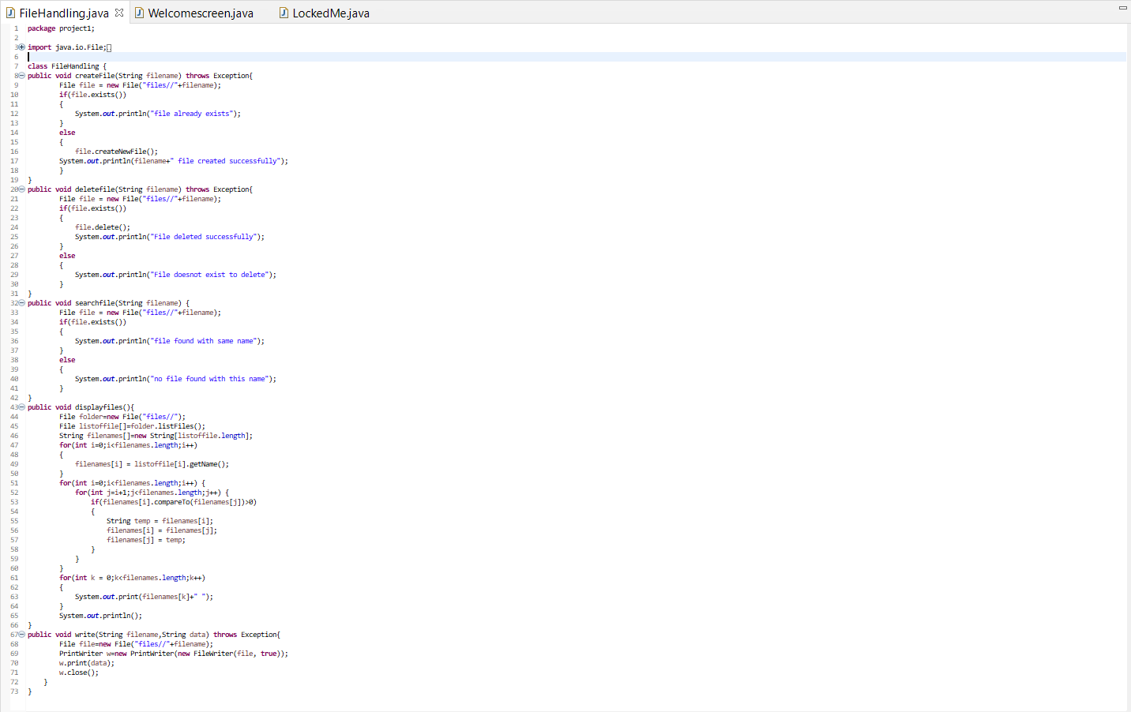

|  |  |
| --- | --- |
| Scanner class | Scanner class is used for taking inputs from user. |
| Switch case | Switch case is used for handle all operations according to user’s input. |
| While loop | While loop is user for executing switch case again and again while user don’t want to exit application. |
| Bubble Sorting | Bubble Sorting is used for sorting the names of files and prints in ascending order. |

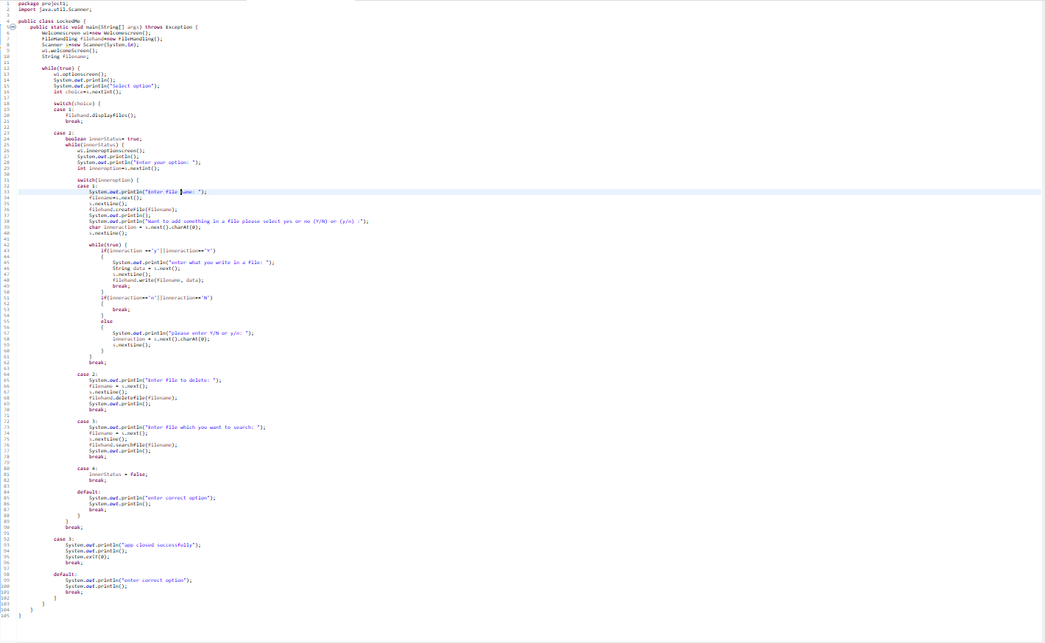

Final output:

